**CSC4001 PROJECT PROPOSAL**

**Miner’s Coffee, A Powerful and Accessible GPU Mining Software**

118010220 Ma Haotian

118010224 Mao Yu

118010335 Wu Wei

118010416 Zhang Shiqi

**Exclusive summary**

To provide more powerful functions and better user experiences, our group has initiated a next-generation GPU mining software named Miner’s Coffee. Compared with existing software of the same type, it integrates more system utilities for state monitoring and hardware configuration, more interactions with end-users, and more elegant graphical representations of data. During the design of this software, we have applied a wide range of software engineering expertise. We have adopted the agile software process for higher flexibility and scalability. Furthermore, we have taken advantage of various UML diagrams to assist design as well as illustration.

**Background**

Since the end of 2020, the price of Bitcoin (BTC) has been increasing rapidly. This sharp rise has stimulated the whole market of cryptocurrencies. Consequently, the mining of tokens based on the Proof of Work (PoW) mechanism has been more than popular around the world. Some of these types of tokens, for instance, BTC, BCH, and LTC need application-specific integrated circuits (ASIC) for mining, while others can be mined using GPU of PC. Among the latter, Ether (ETH) of Ethereum is the most favored since it provides the highest profit.

**Problems**

Currently, ETH miners can choose between two kinds of software. One is open-source mining programs with no graphical user interface (GUI), the other is closed-source commercial mining software with GUI and some additional functionalities such as temperature monitoring and virtual memory setting. Unfortunately, both types of software have some shortcomings. The open-source ones are not user-friendly due to the lack of GUI. Users have to learn and type command lines to configure and run the program, which could be annoying for unsophisticated users. Furthermore, this type of mining program can do nothing but mining. That is, users need to use other software to monitor temperatures, set the size of virtual memory, and/or check network latency, which is inconvenient. On the other hand, although the commercial ones implement GUI and integrate some utilities, they have the following drawbacks: First, they take 1-5 percent of mining output as their profit, which could be a significant loss for users in the long run. Second, their functionalities are still insufficient. For example, they provide neither an estimation of the daily output in dollars nor statistics on computational power and temperature. Besides, some of them do not supply utilities for GPU overclocking. The ones which do provide overclocking setting do not provide automatic overclocking. Users must set the overclocking parameters by themselves, test system performance and stability, and then adjust the overclocking parameters accordingly. To achieve optimization of the system, users may need to repeat the above process for multiple rounds, which could be time-consuming and tiring. Third, their user experiences are unsatisfactory. In terms of the user interface, their GUIs are filled with texts and lack graphs, which are neither concise nor elegant. As for interoperability, they do not provide sufficient tips or feedback. For instance, on the overclocking setting panel of Easy Miner, there is no prompt about the parameters. For naïve users, this may confuse them. Worse still, if the naïve users set the parameters improperly, the hardware can be damaged. Moreover, there is no notification when the system is not running smoothly. For example, if the cooling of hardware is poor or the clock frequency of the GPU is set too high, the power of the GPU will be reduced compulsively by the driver. As a result, the computational power will decrease. However, in this kind of situation, this software does not notify the users directly. Users can realize the problem only by checking the status manually and actively.

**Solution**

Our solution is a powerful GPU mining software named Miner's Coffee, which integrates an open-source mining program with utilities for monitoring, overclocking, and tracking. First things first, once purchased, Miner's Coffee takes no cut. This charging method would be more economical in the long run. At the bottom, it employs NBMiner, one of the most famous open-source ETH mining programs, as the mining core. Concerning utilities, it provides the following functionalities: real-time GPU hash rate, temperature, power, and frequency monitoring; GPU core frequency, memory frequency, power limit, and fan speed setting; statistics on hash rate, temperature, and power consumption; estimation of the daily output in dollars; warnings and suggestions about cooling and overclocking; automatic overclocking. Last but not the least, Miner's Coffee adopts a graceful GUI, which contains a series of line graphs, gauges, and other graphical components. In summary, Miner's Coffee will provide an easy, economical, and elegant ETH mining experience.

**Objectives**

To ensure the functionality, reliablity, and accessibility of our final product, we will accomplish the following objectives during the development process:

1. Design the system architecture:
   1. Experience the mainstream GPU mining software and summarize their general system architectures.
   2. Identify their advantages and disadvantages.
   3. Summarize inspirations and propose improvements.
   4. Establish the initial system architecture of our product.
   5. Communicate with the miner community for suggestions. Revise the system architecture if necessary. This step might be repeated multiple times until stability.
2. Implement the prototype:

Develop the product according to the system framework and implement all the designed functions.

1. Test and perfect the product:
   1. Develop test programs to achieve test automation.
   2. Comprehensively test the product and fix problems iteratively until stability.
   3. Invite users to test the program. Collect problem reports and suggestions. Update the product according to the user feedback if necessary. This step might be repeated multiple times until stability.
2. Release the open beta and get more feedback from board users to further improve the product.

**Benefits**

By integrating the core features of the mainstream miner program, our product is well-equipped features that will satisfy the miner users' basic needs. By designing the UI elaborately, our product will be more beautiful and user-friendly. Plus, by adding additional functions like the estimated earnings and real-time hash rate curves, users can have a more concise understanding of the current status of mining. Unlike some products that charge the user some portion of their gains as commission, our product only charges the users once for installation which will be more economical.

**Advantages**

We are experienced in blockchain technologies especially GPU mining, which ensures our product can be designed in an all-around manner to provide a better user experience. Also, members of the development team have experiences in a number of small and medium-sized projects, which guarantees the quality of our product. With passion and expertise in software engineering, we will present a powerful, accessible, and reliable GPU mining software for the miner community.

**Timeline**

1. 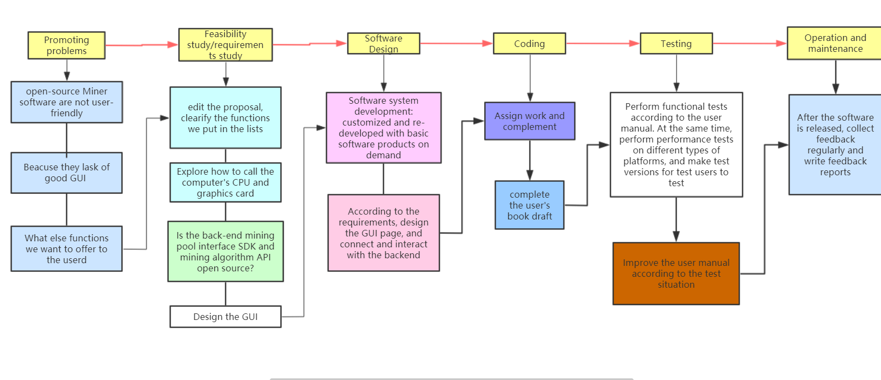software design process

*Figure 1: Software Design process*

1. Schedule

|  |  |  |
| --- | --- | --- |
| Phase | Description | END DATE |
| PROMOTING PROBLEM | Promoting problem | 20/3/2021 |
| Feasibility study | Study the current problem and find the feasibility of the problem | 26/3/2021 |
| Software Design | Design functions | 5/4/2021 |
| Coding | Implement functions | 25/4/2021 |
| Testing | Find possible problems | 30/4/2021 |
| Operation and Maintenance |  |  |

*Table 1: time schedule*

**UML Diagrams**

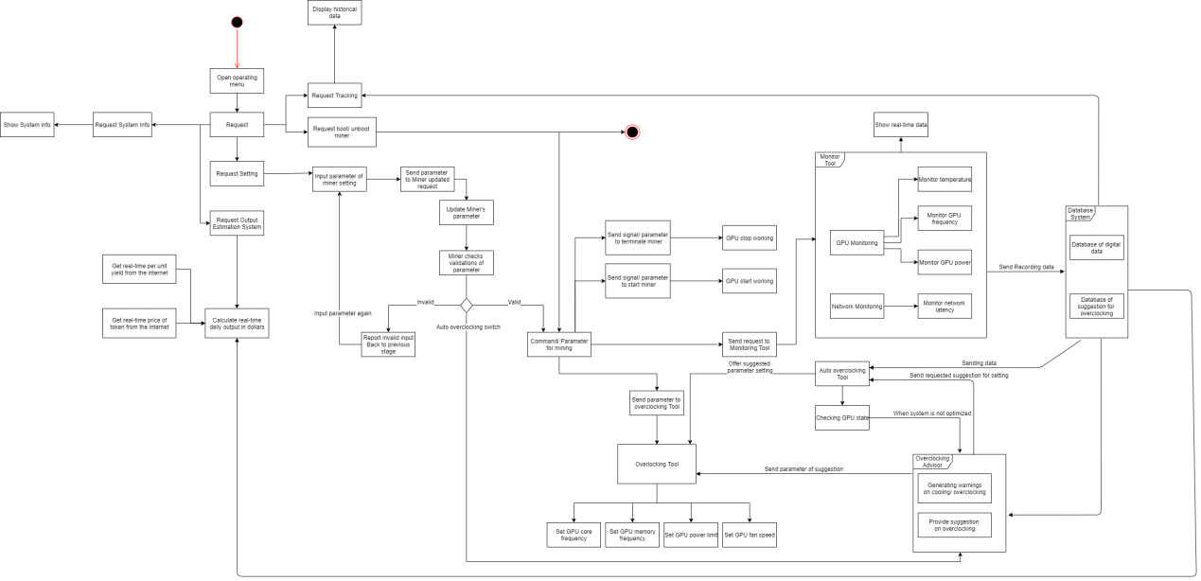

*Figure 2: Activity_graph*

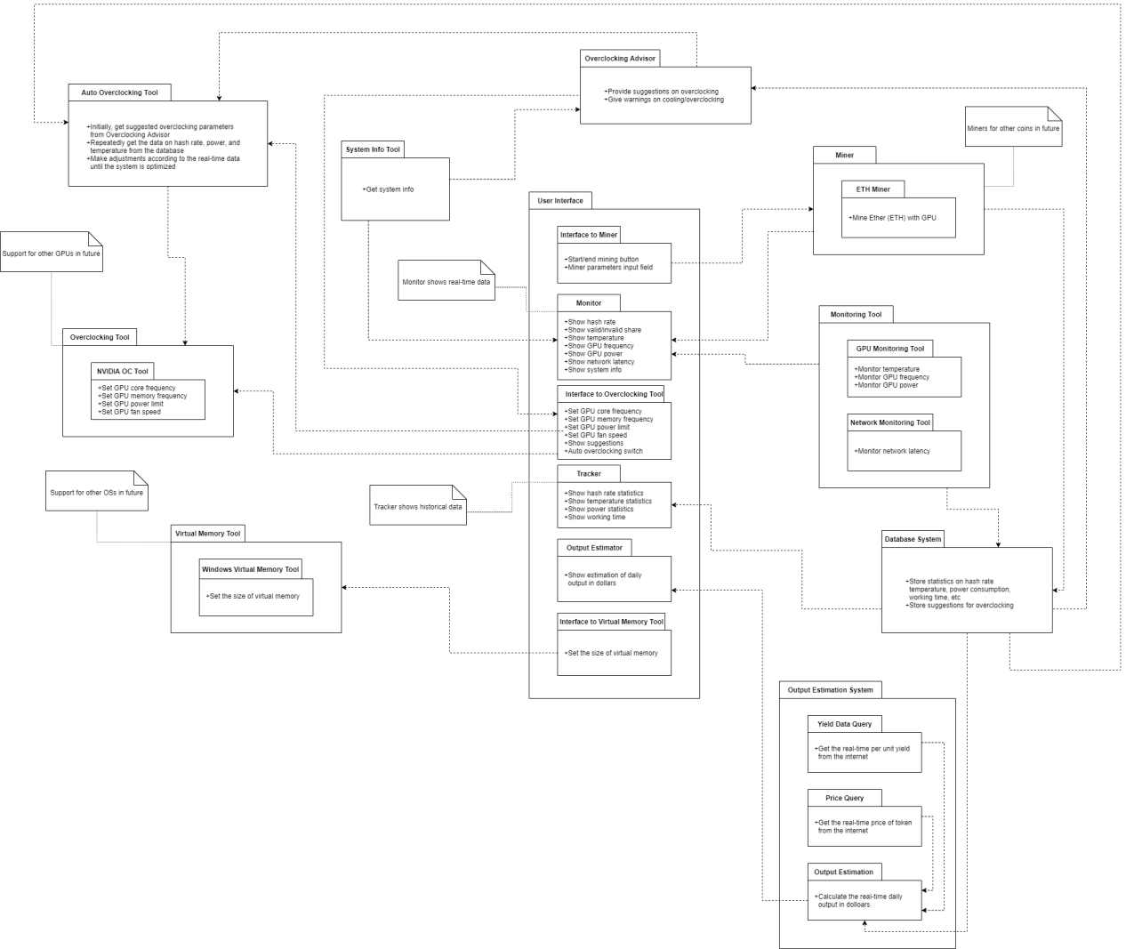

*Figure 3: Conceptual-view*

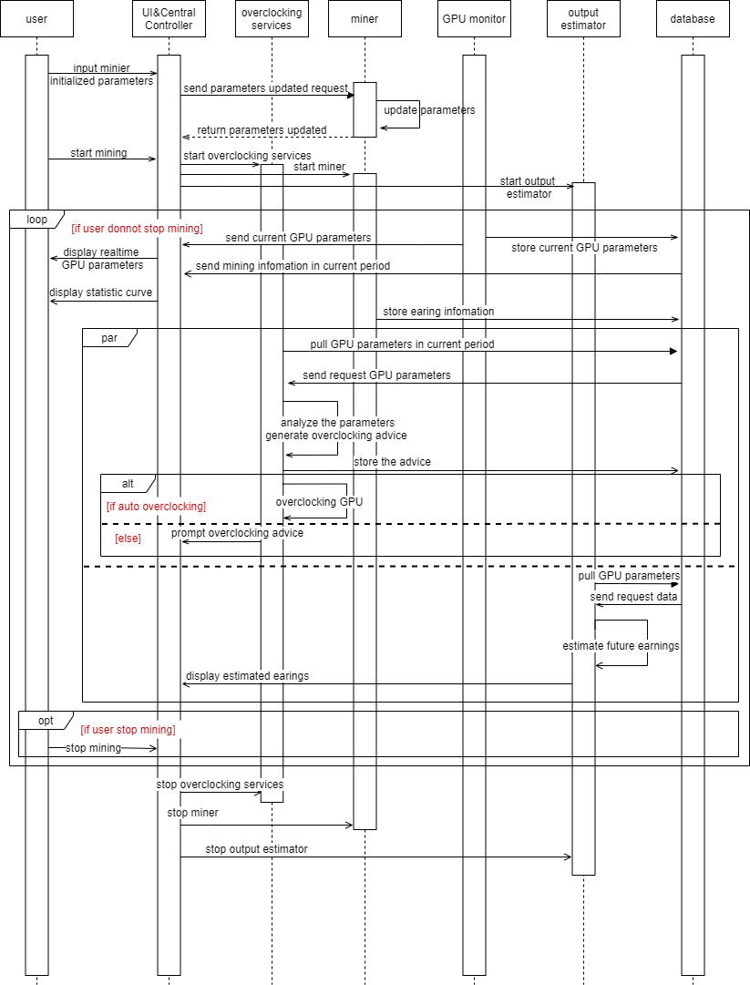

*Figure 4: Sequential-Diagram*

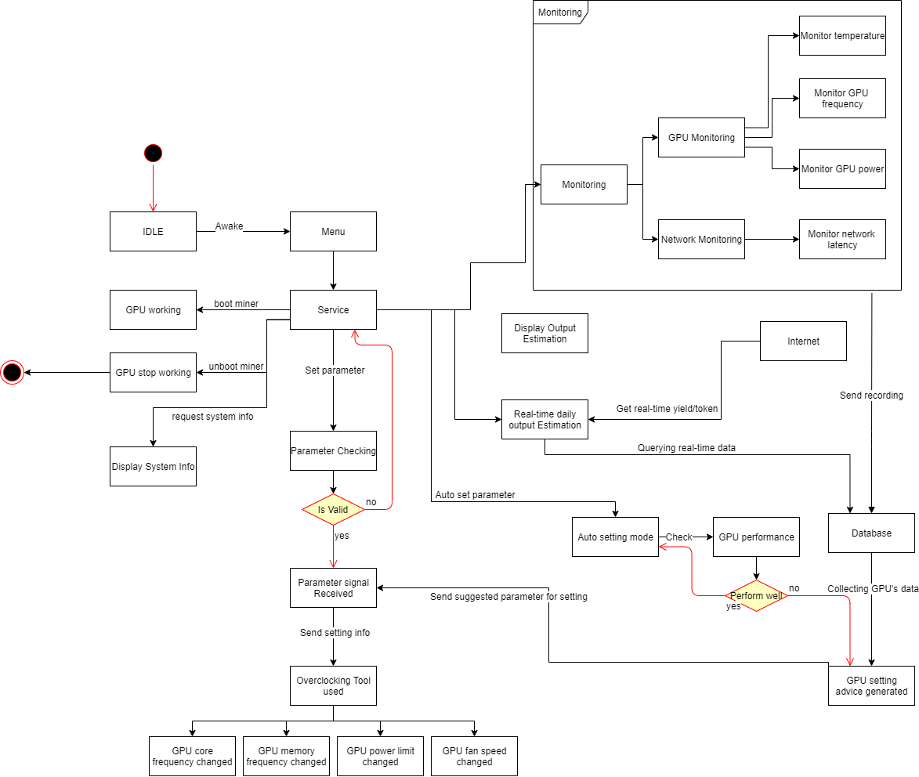

*Figure 5: State_graph*

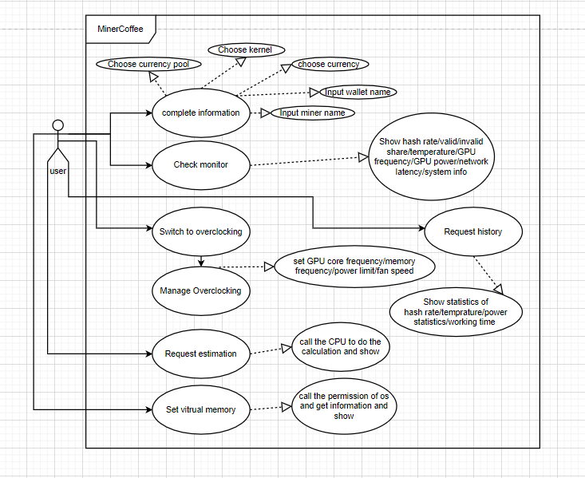

*Figure 6: User_case*